Name: _______________________________________

Lesson 9: Insert and Update

1. Using the following Link <https://github.com/niteen11/cuny_lagcc_micro_credential_data_analytics/tree/main/Track%20A/Unit%205%20-%20SQL_%20Relational%20Databases/guided%20exercise>

First you have to create a table than upload the data ,safe the table in to your Laptop and change the path accordingly.usr the following link for creating table,

<https://github.com/niteen11/cuny_lagcc_micro_credential_data_analytics/blob/main/Track%20A/Unit%205%20-%20SQL_%20Relational%20Databases/guided%20exercise/student.sql>

And attached data set (Student_data and Student_marks ) answer the following questions :

1. Students with the highest unit4 marks

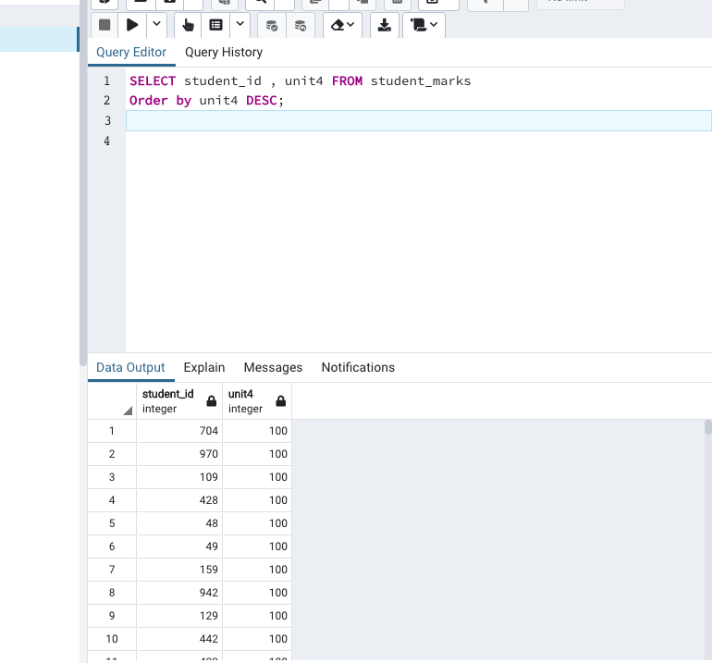

|  |  |
| --- | --- |
|  |  |
|  | -- Find students scored between 89 and 100 unit4 |
|  |  |
|  | Open ended questions: |
|  | -- Take a closer look at the tables that you created and come up with 10 different scenarios/ questions and form SQL |
|  | -- Ask your colleagues |

1. How many different integer grades were in unit5?

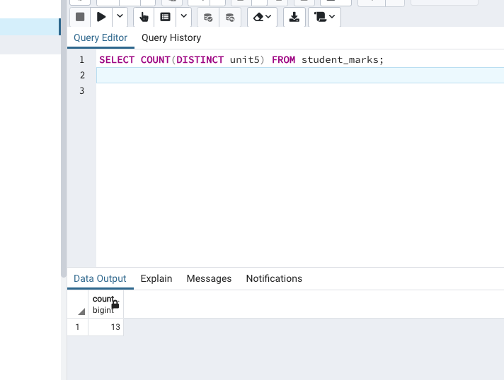

1. How many students had both a 100 integer grade in both unit2 and unit5 ?

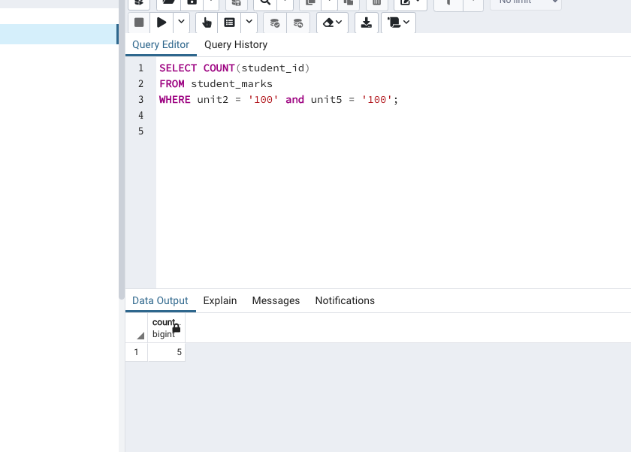

1. Find the average score for unit3.

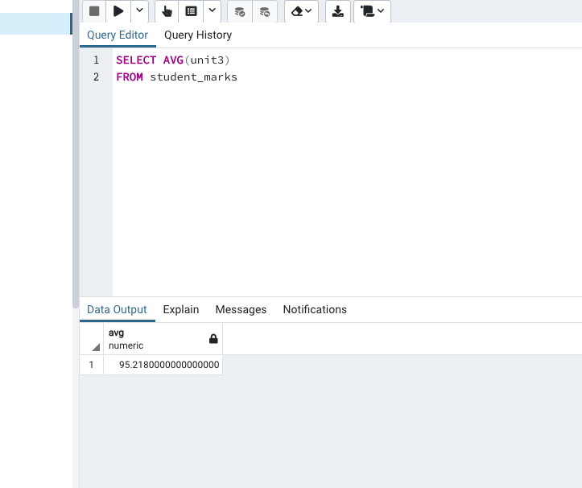

1. Find the work phone for the student whose name is Shina.

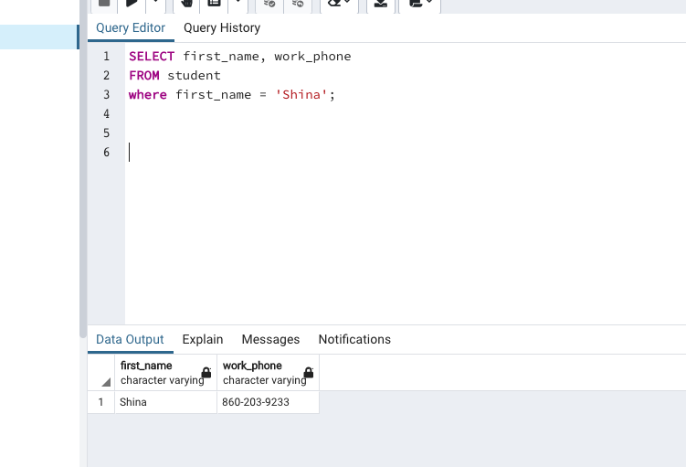

1. The professor wants to take attendance by alphabetical order. Write a command where the names are listed in alphabetical order.

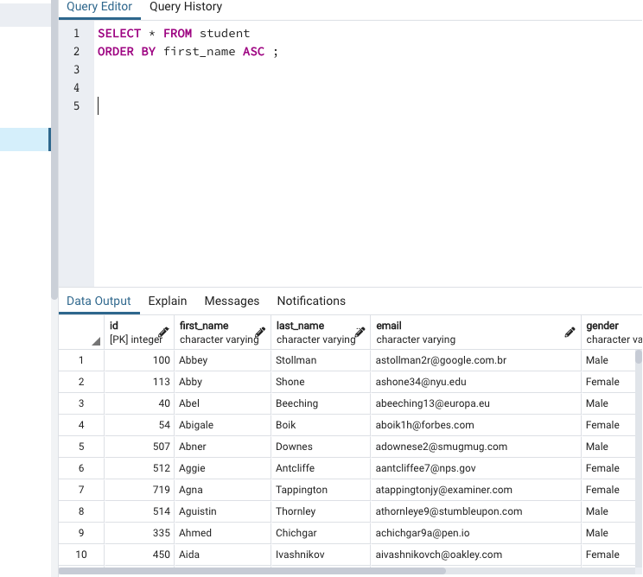

1. Count how many students are named ALANA.

